**Контроль версий углублённо (GIT). Обучение в записи**

**Урок 6. Семинар: Практики и инструменты для работы с Git**



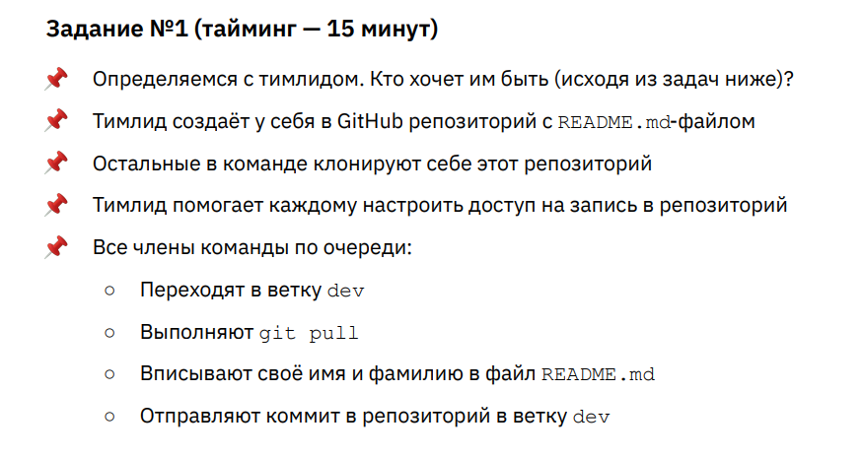

**Ход выполнения задания 1.**

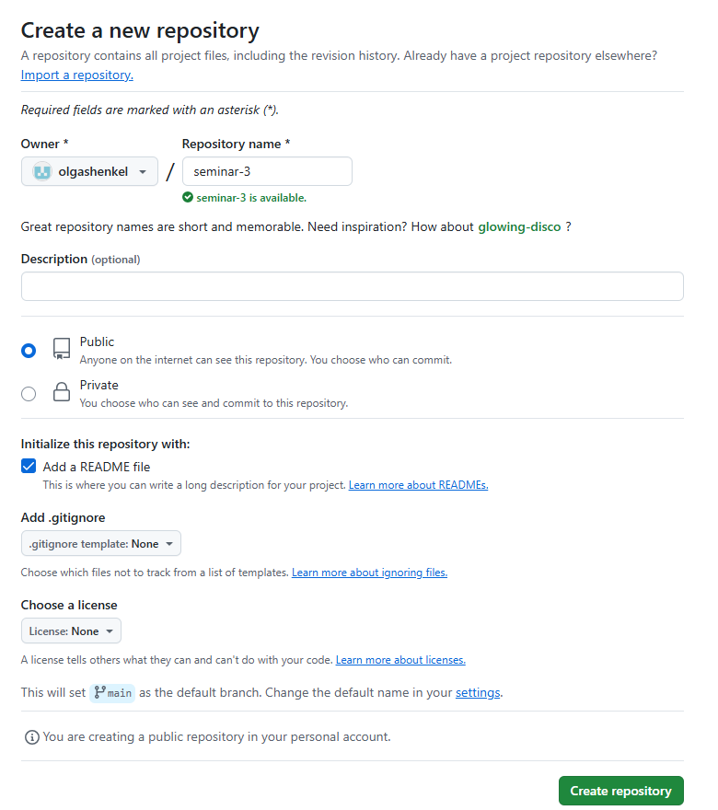

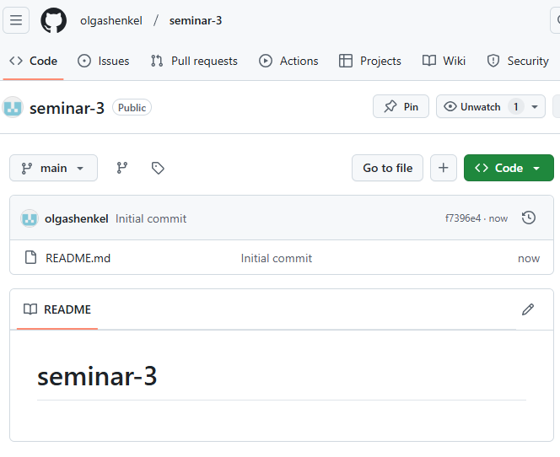

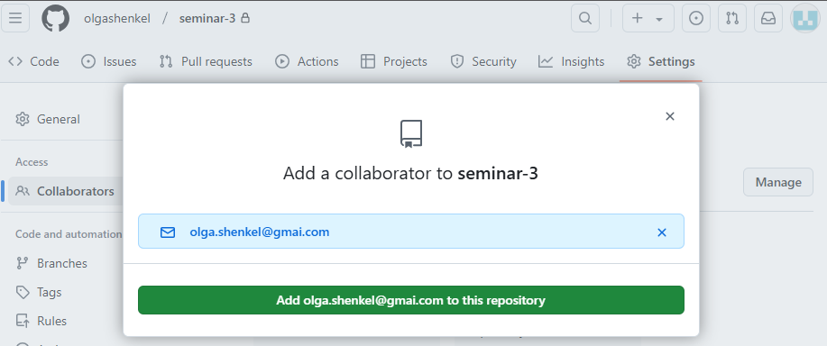

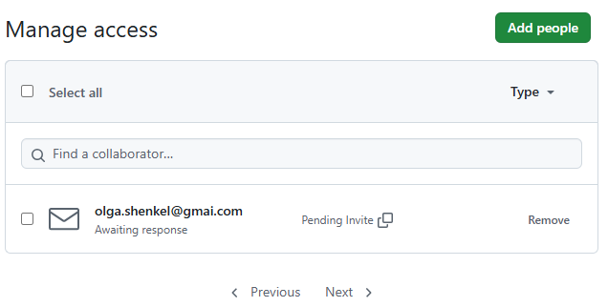

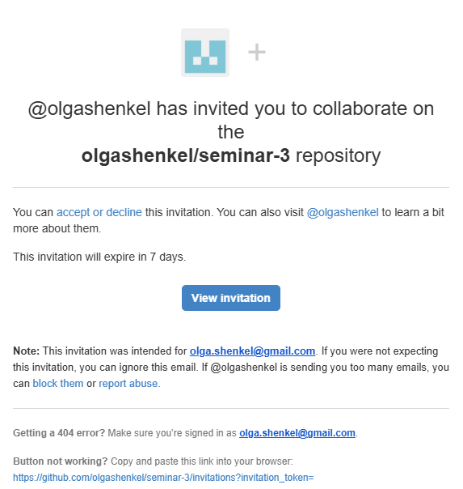

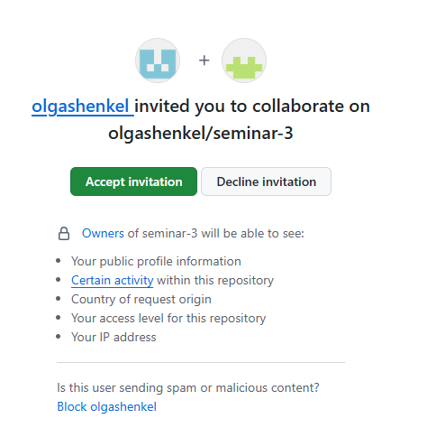

user@DESKTOP-929P2AG MINGW64 /

$ cd ~/Desktop/seminar-3/

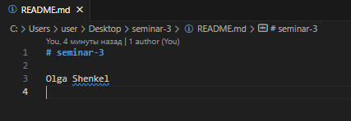

user@DESKTOP-929P2AG MINGW64 ~/Desktop/seminar-3 (dev)

$ git status

On branch dev

Changes not staged for commit:

(use "git add <file>..." to update what will be committed)

(use "git restore <file>..." to discard changes in working directory)

modified: README.md

no changes added to commit (use "git add" and/or "git commit -a")

user@DESKTOP-929P2AG MINGW64 ~/Desktop/seminar-3 (dev)

$ git add .

user@DESKTOP-929P2AG MINGW64 ~/Desktop/seminar-3 (dev)

$ git commit -m "update README.md"

[dev 98d2205] update README.md

1 file changed, 1 insertion(+), 1 deletion(-)

user@DESKTOP-929P2AG MINGW64 ~/Desktop/seminar-3 (dev)

$ git push

fatal: The current branch dev has no upstream branch.

To push the current branch and set the remote as upstream, use

git push --set-upstream origin dev

To have this happen automatically for branches without a tracking

upstream, see 'push.autoSetupRemote' in 'git help config'.

user@DESKTOP-929P2AG MINGW64 ~/Desktop/seminar-3 (dev)

$ git push origin dev

Enumerating objects: 5, done.

Counting objects: 100% (5/5), done.

Writing objects: 100% (3/3), 277 bytes | 277.00 KiB/s, done.

Total 3 (delta 0), reused 0 (delta 0), pack-reused 0

To github.com:olgashenkel/seminar-3.git

9a2ce37..98d2205 dev -> dev

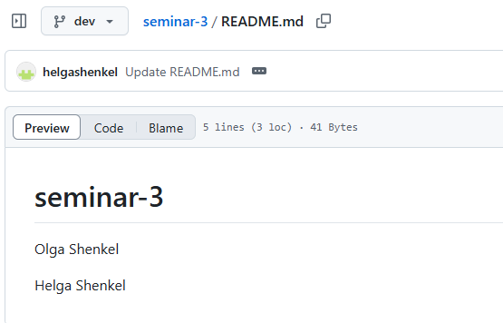

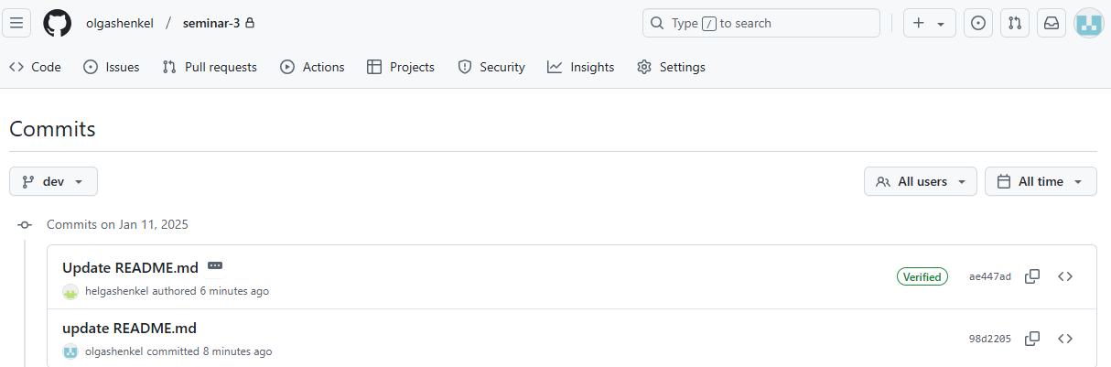

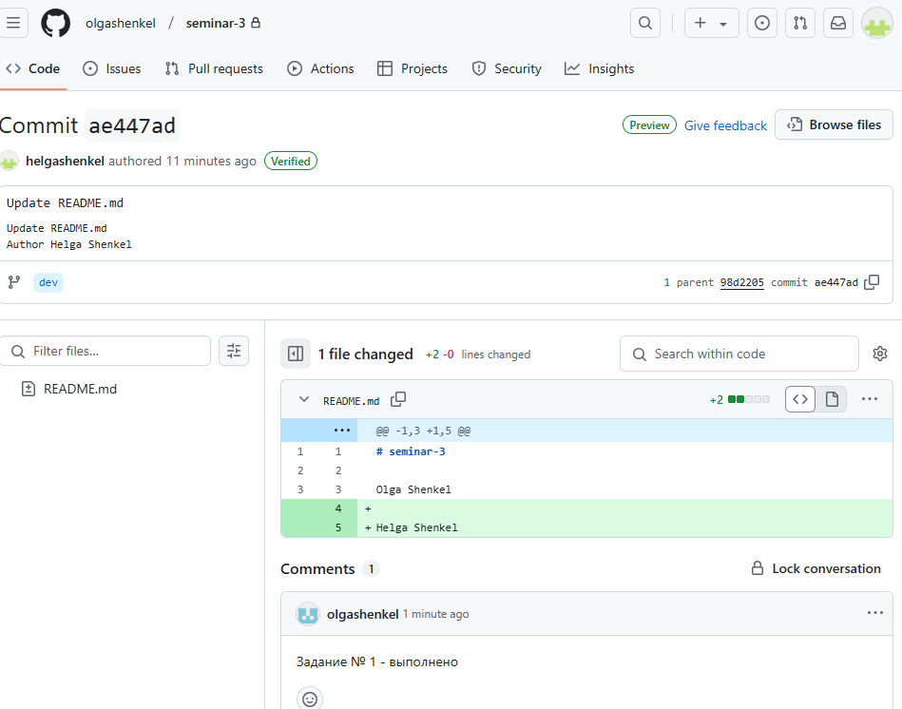

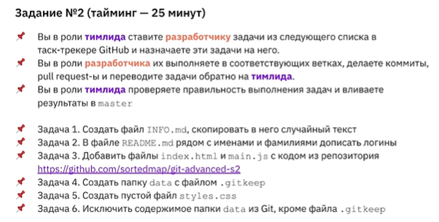

**Ход выполнения задания 2.1.**

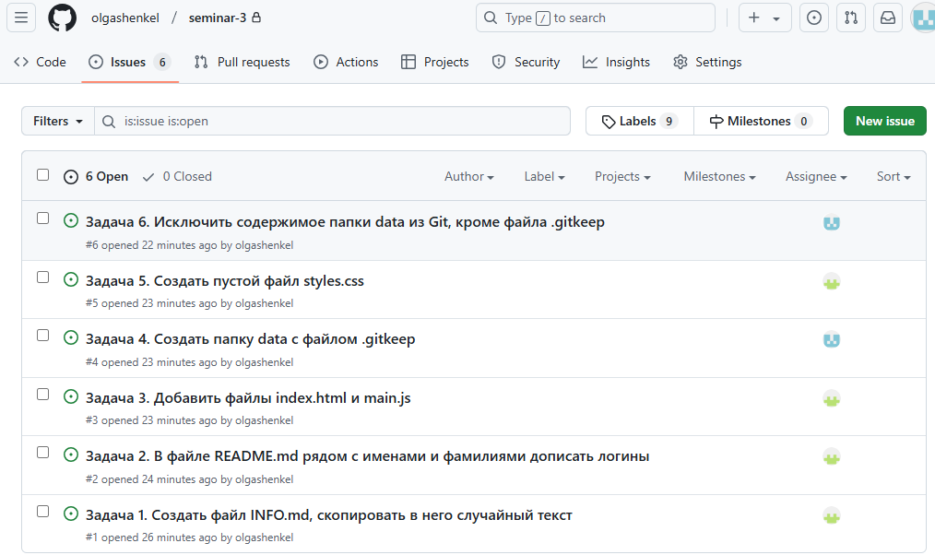

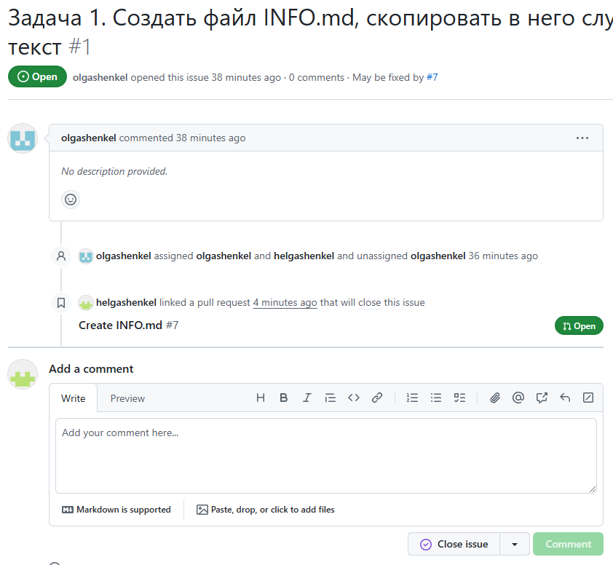

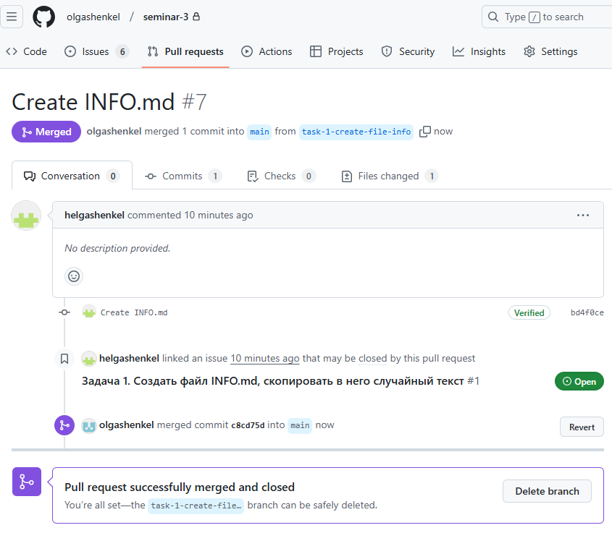

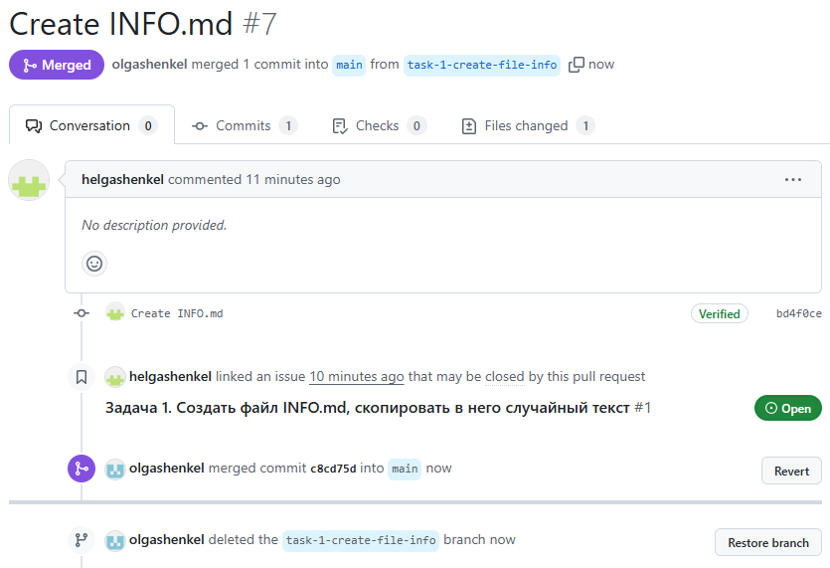

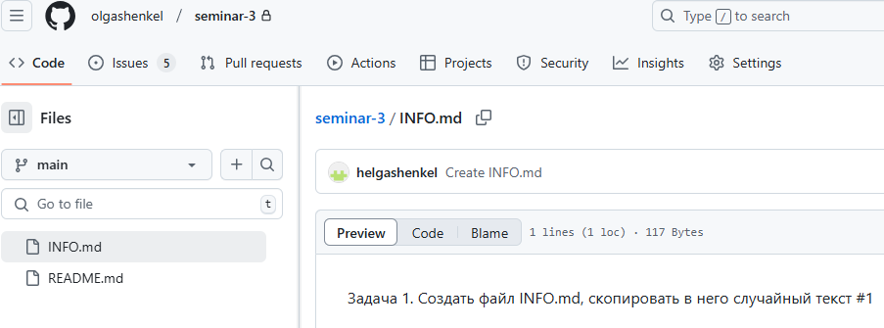

**Ход выполнения задания 2.2.**

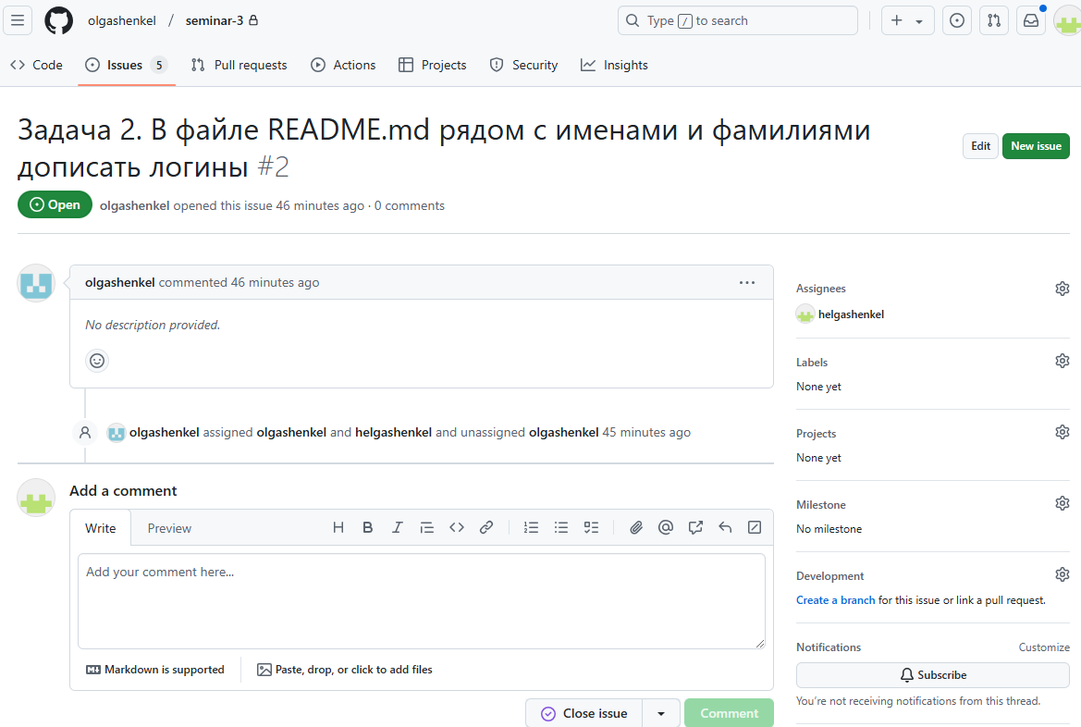 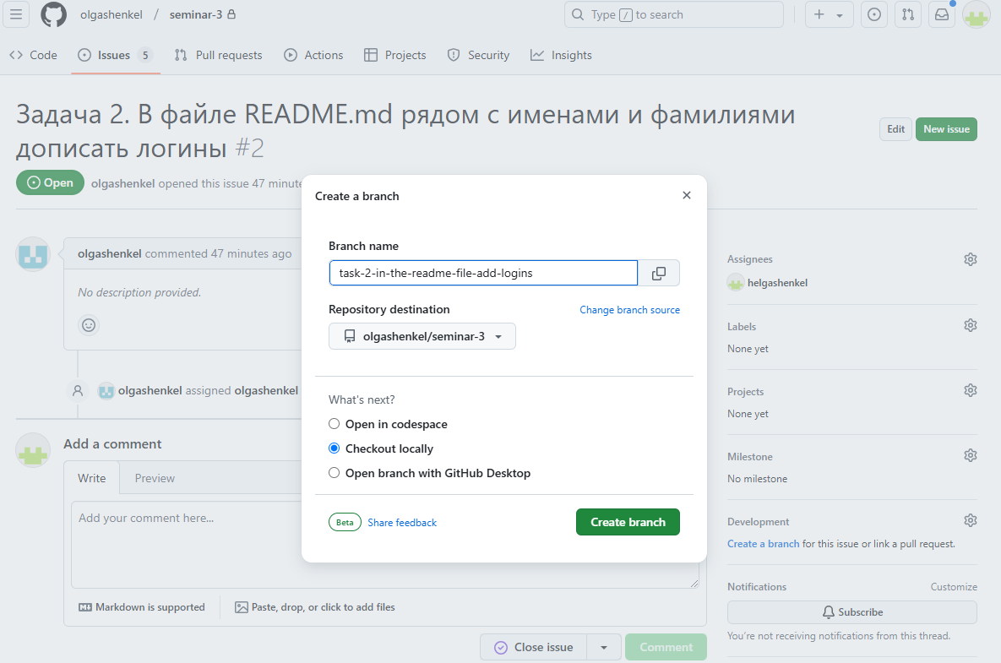

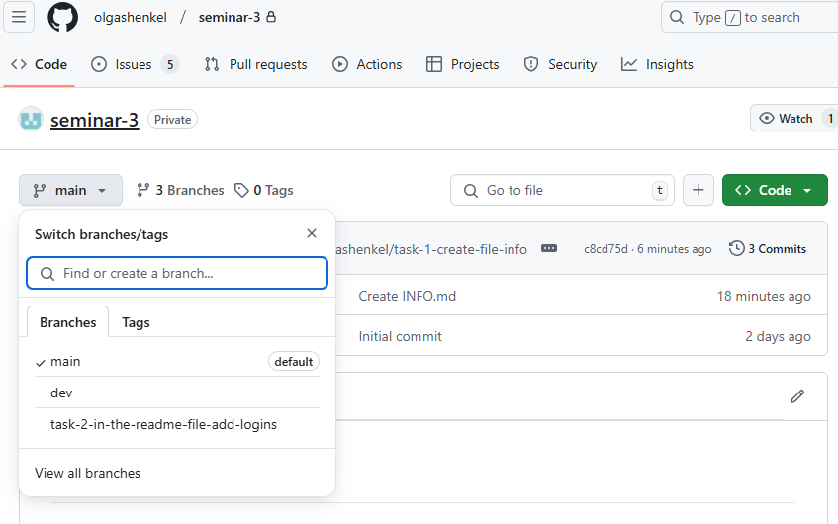 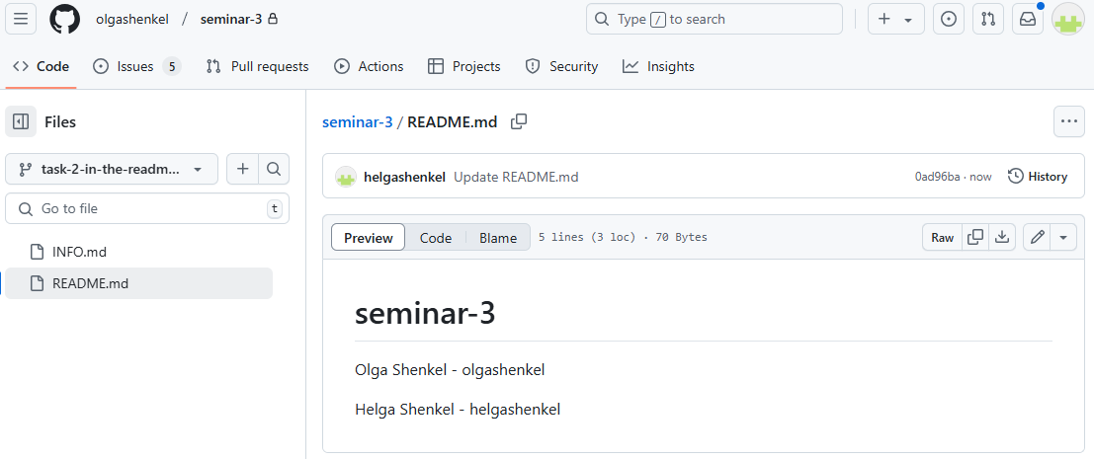

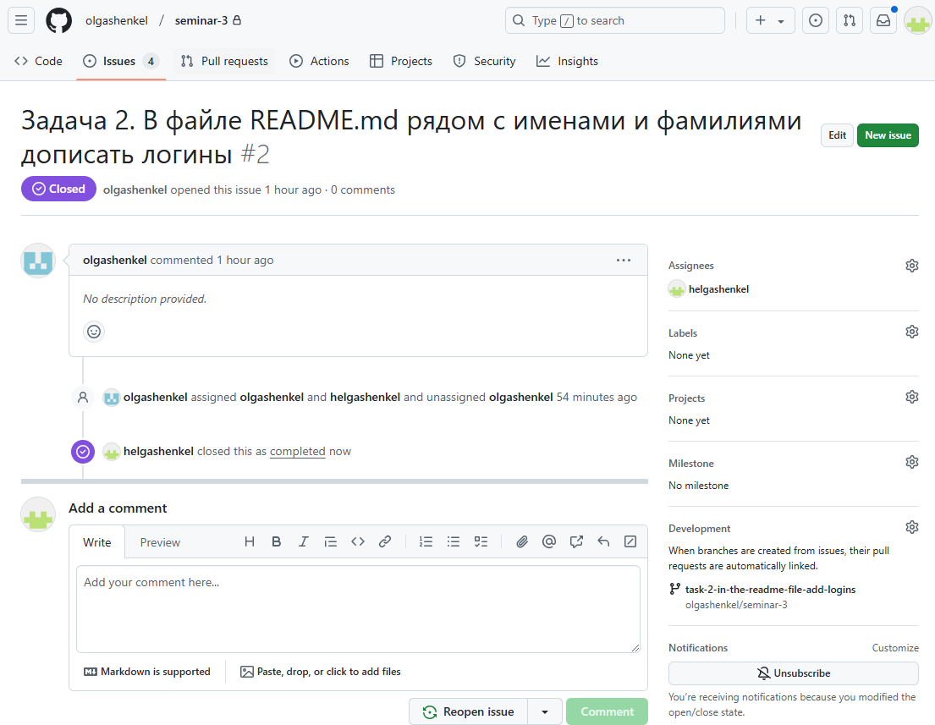 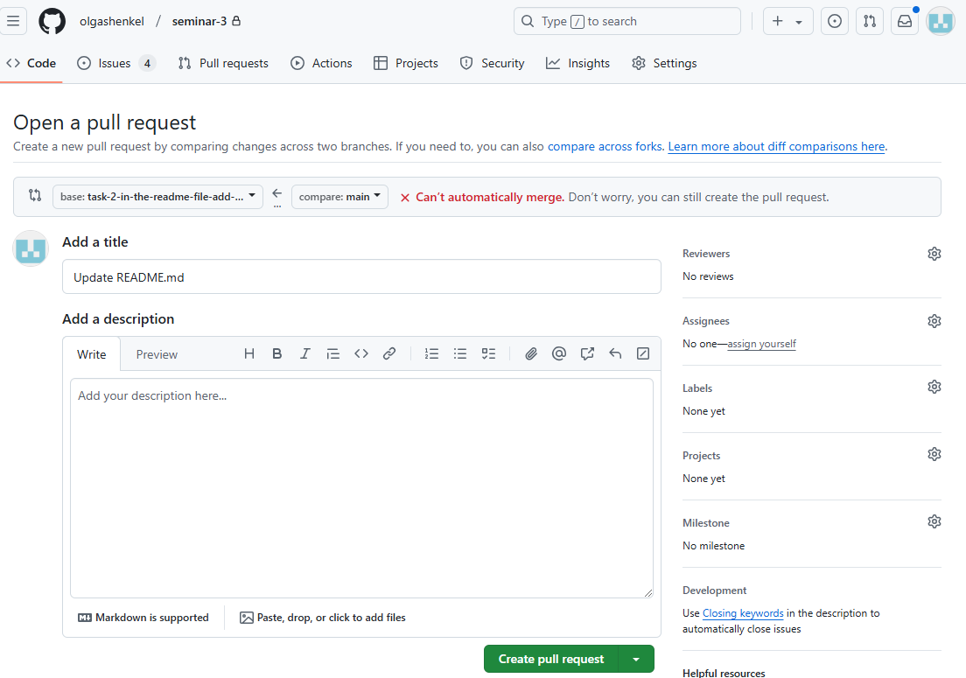

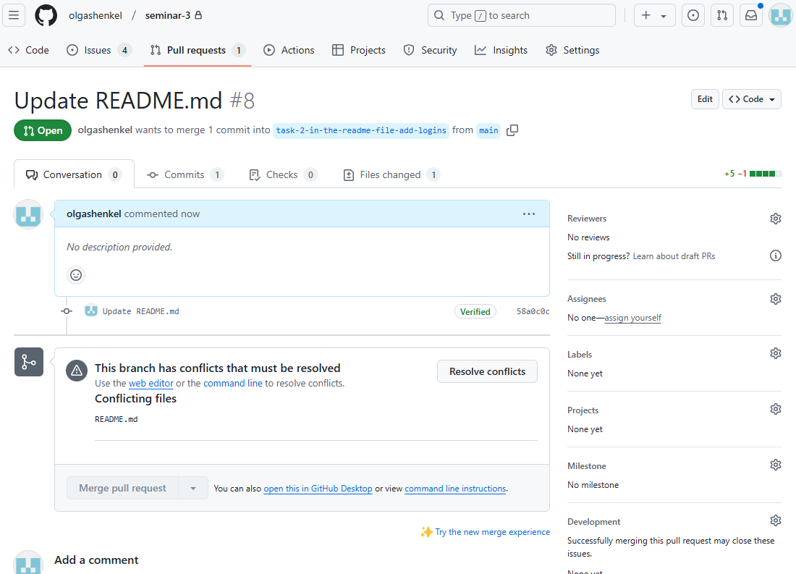 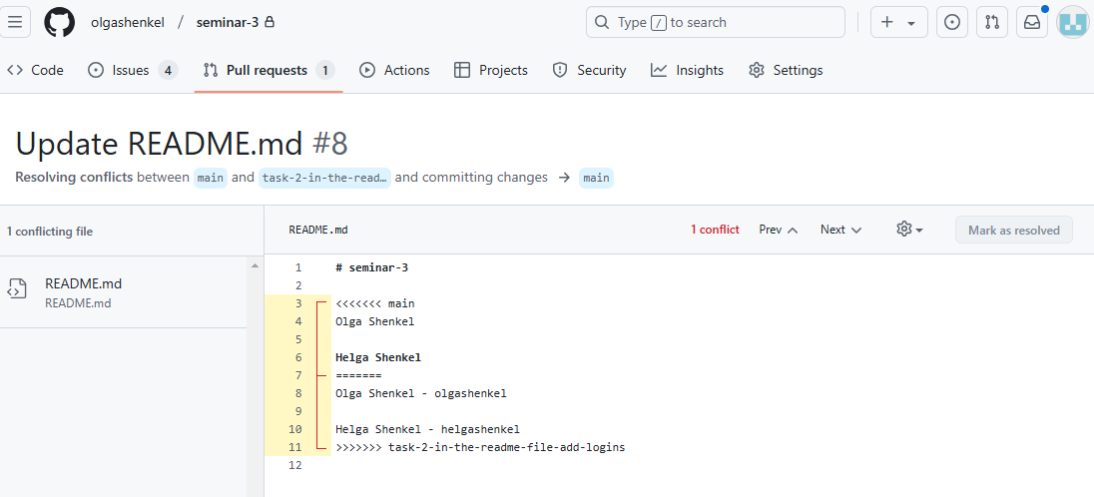

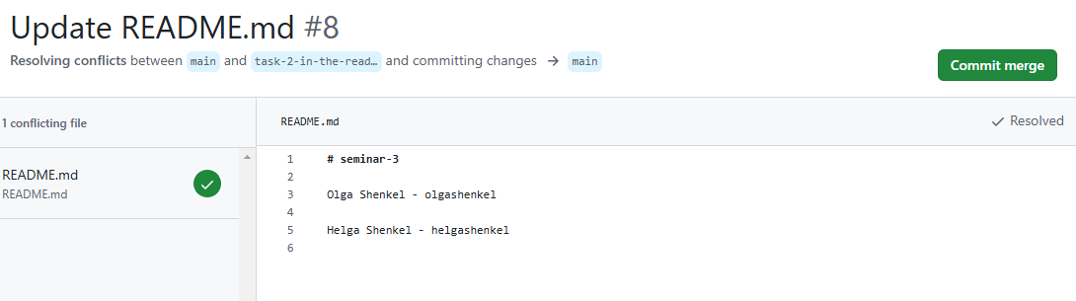

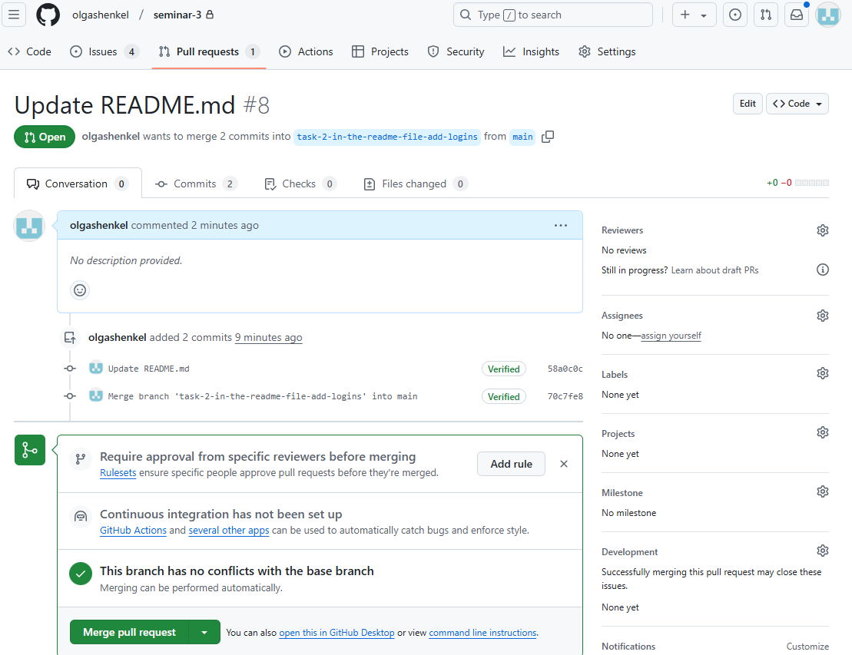 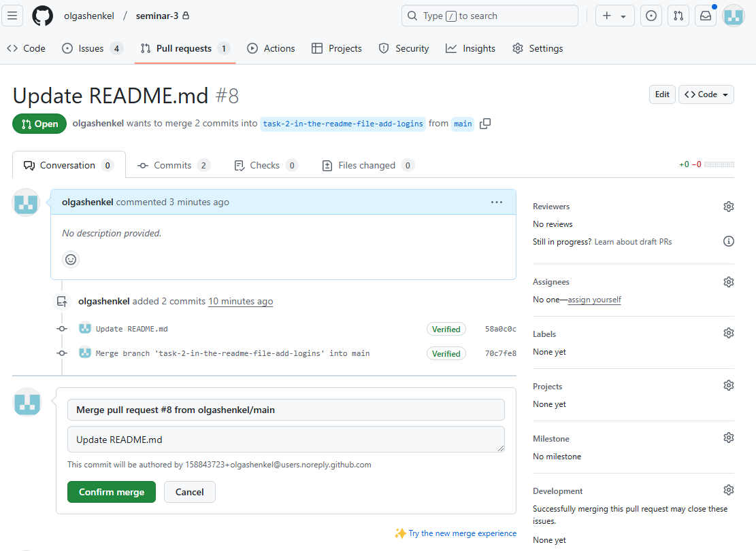

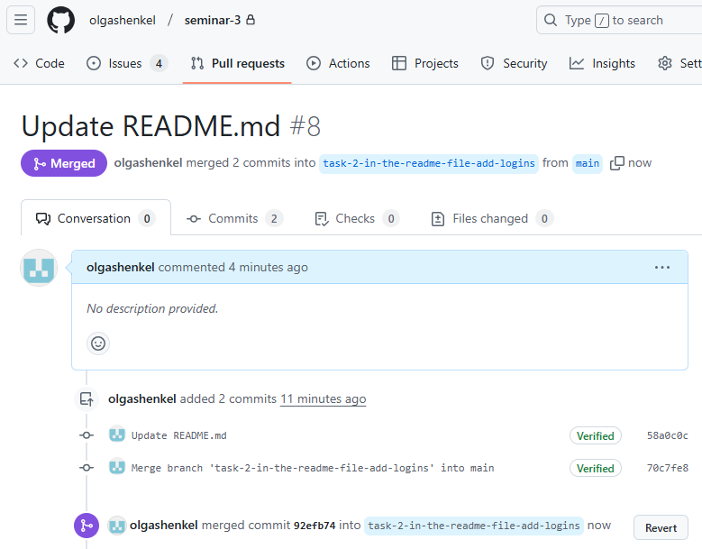 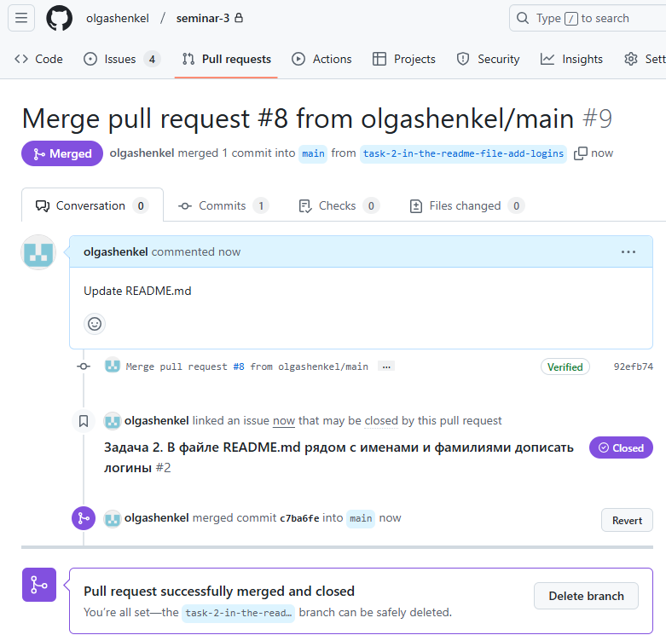

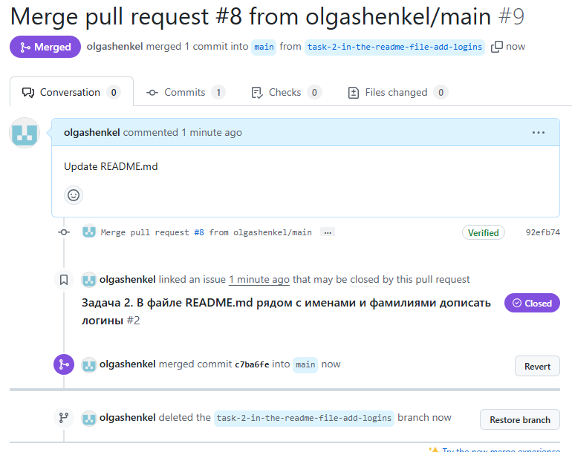

**Ход выполнения задания 2.3.**

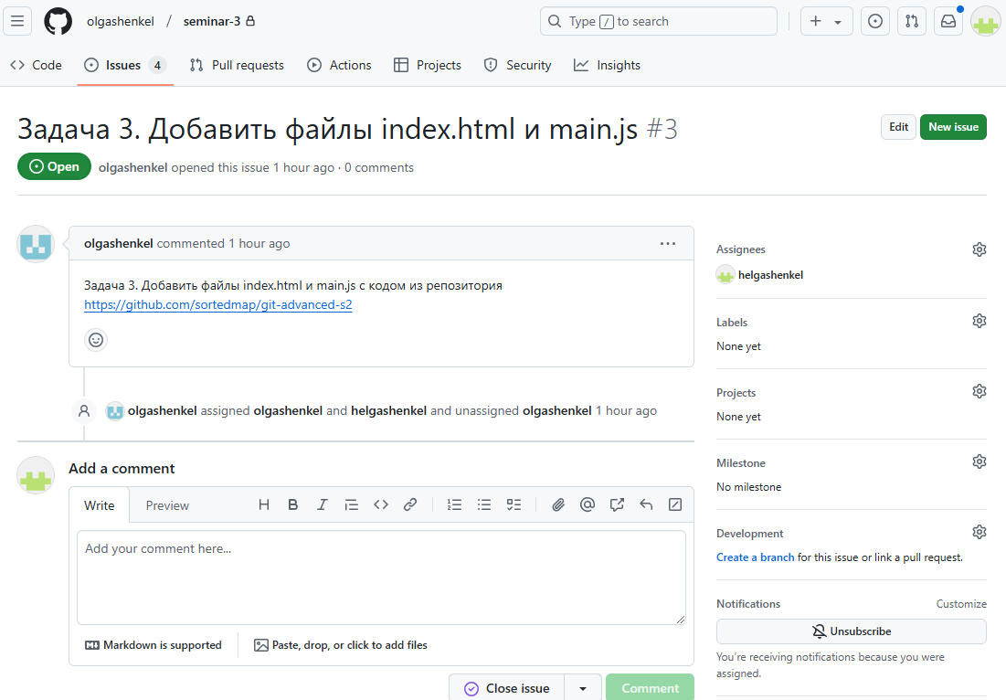 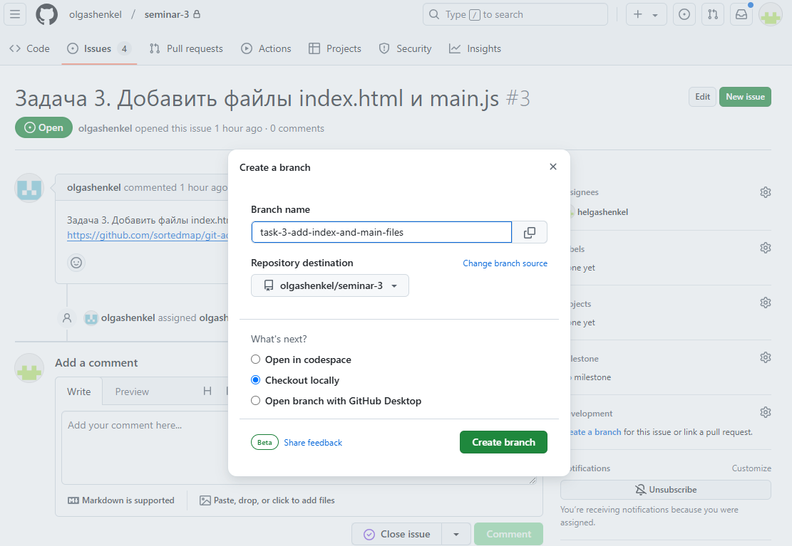

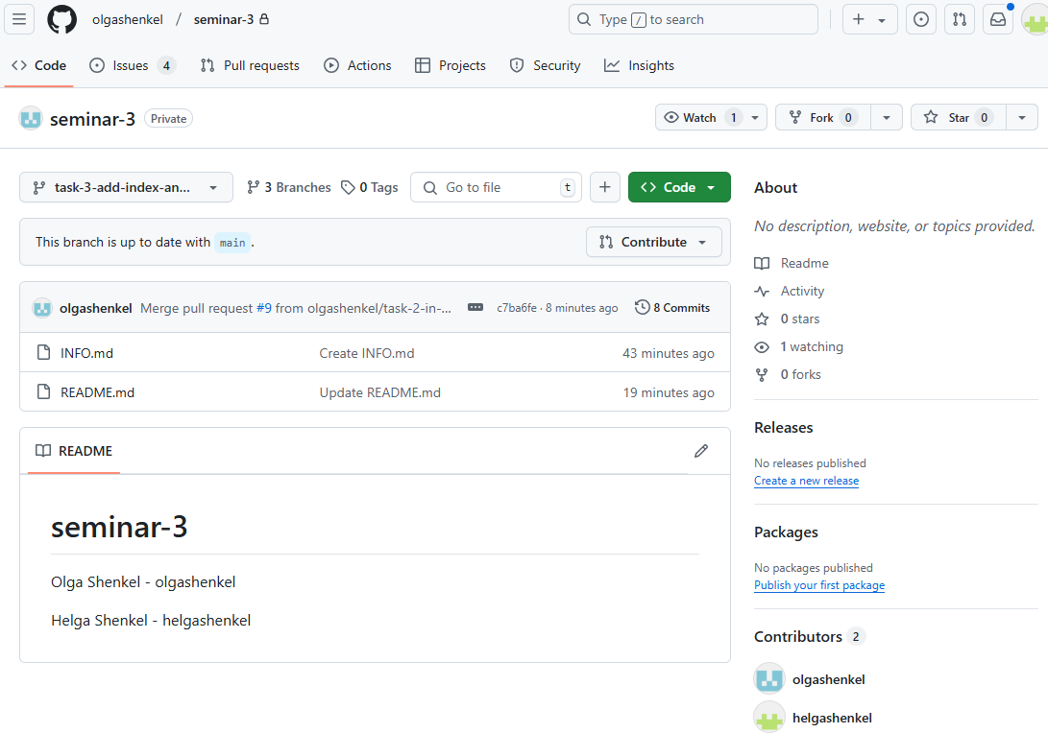 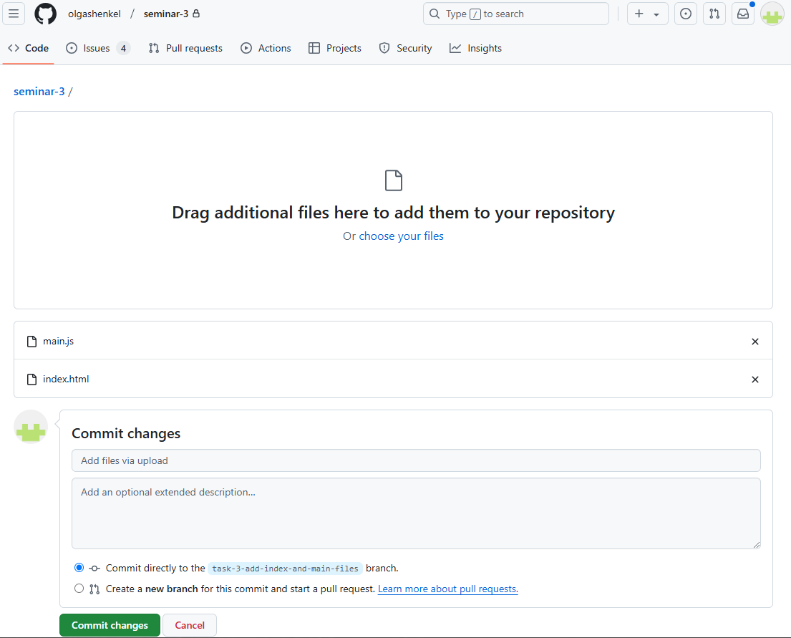

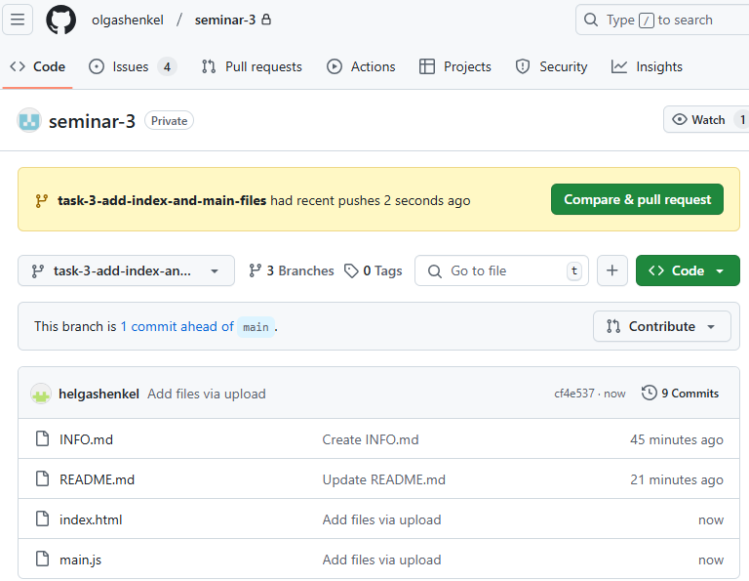 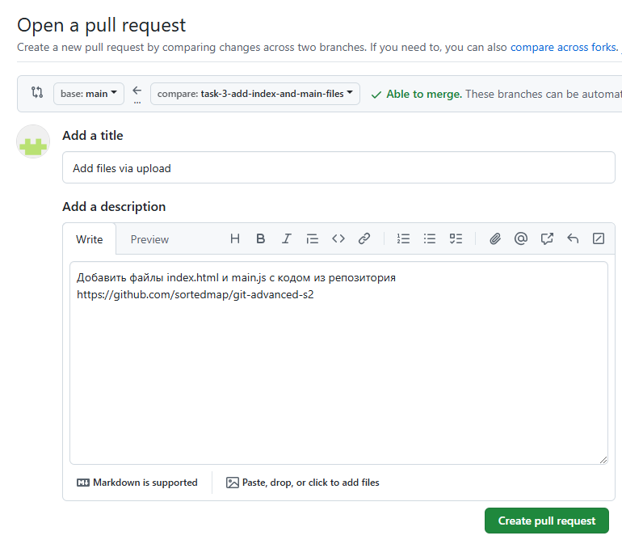

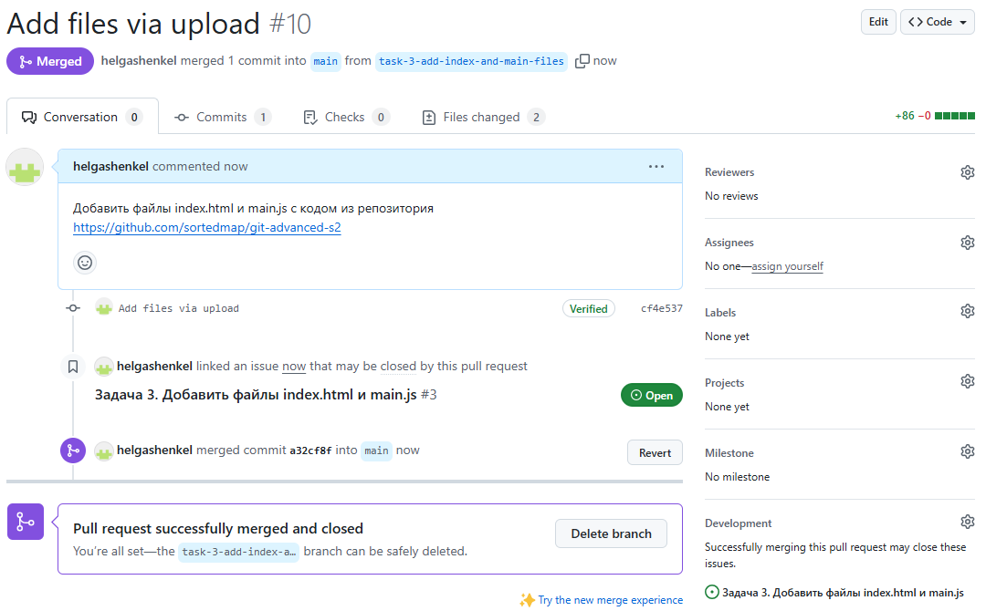 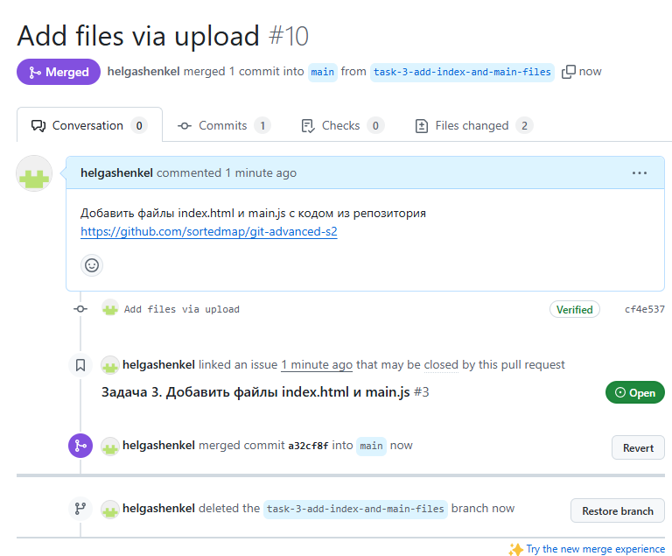

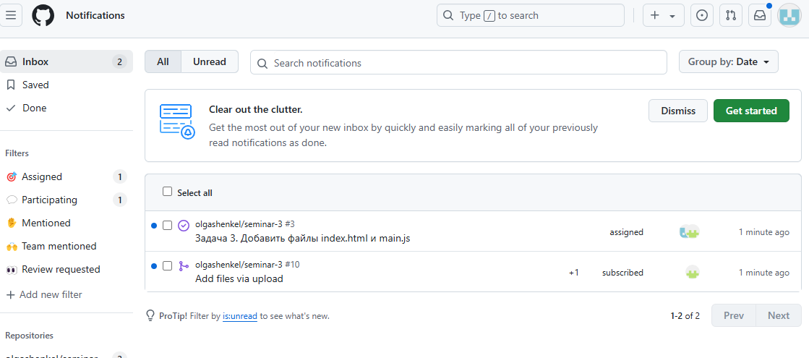

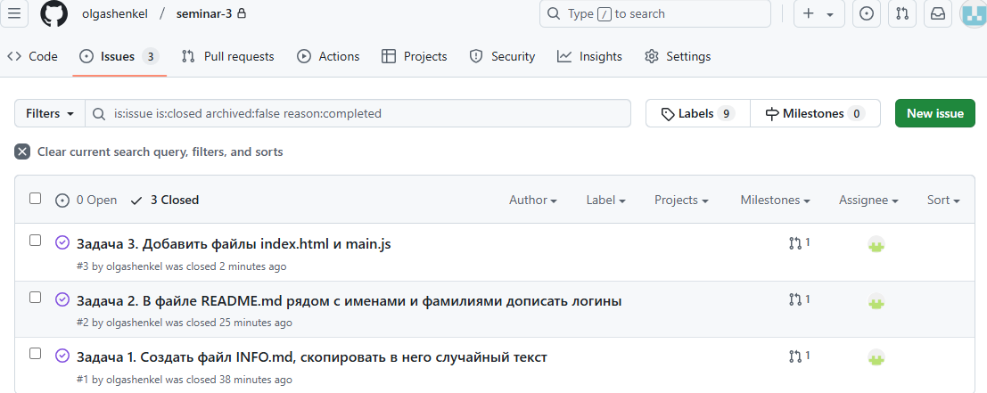

**Ход выполнения задания 2.4.**

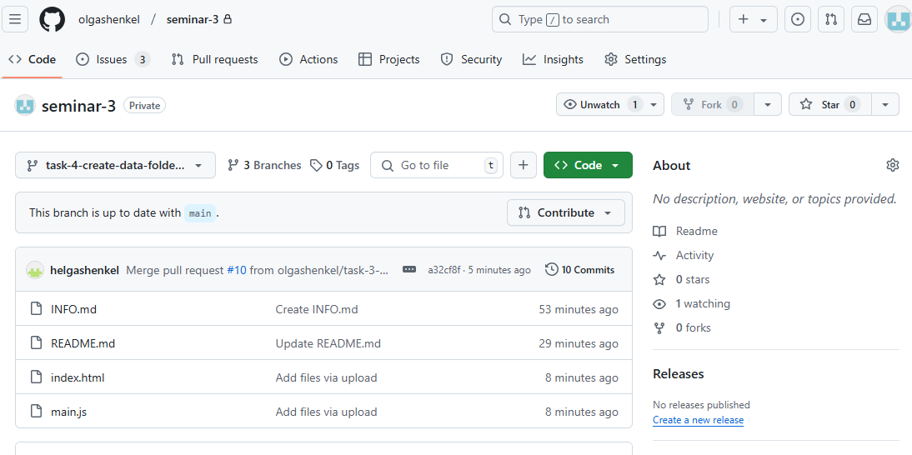

*user@DESKTOP-929P2AG MINGW64 ~/Desktop/seminar-3 (main)*

*$ git pull*

*From github.com:olgashenkel/seminar-3*

*\* [new branch] task-4-create-data-folder-with-gitkeep-file -> origin/task-4-create-data-folder-with-gitkeep-file*

*Already up to date.*

*user@DESKTOP-929P2AG MINGW64 ~/Desktop/seminar-3 (main)*

*$ git checkout task-4-create-data-folder-with-gitkeep-file*

*Switched to a new branch 'task-4-create-data-folder-with-gitkeep-file'*

*branch 'task-4-create-data-folder-with-gitkeep-file' set up to track 'origin/task-4-create-data-folder-with-gitkeep-file'.*

*user@DESKTOP-929P2AG MINGW64 ~/Desktop/seminar-3 (task-4-create-data-folder-with-gitkeep-file)*

*$ git status*

*On branch task-4-create-data-folder-with-gitkeep-file*

*Your branch is up to date with 'origin/task-4-create-data-folder-with-gitkeep-file'.*

*Untracked files:*

*(use "git add <file>..." to include in what will be committed)*

*data/*

*nothing added to commit but untracked files present (use "git add" to track)*

*user@DESKTOP-929P2AG MINGW64 ~/Desktop/seminar-3 (task-4-create-data-folder-with-gitkeep-file)*

*$ git add .*

*user@DESKTOP-929P2AG MINGW64 ~/Desktop/seminar-3 (task-4-create-data-folder-with-gitkeep-file)*

*$ git commit -m "add /data"*

*[task-4-create-data-folder-with-gitkeep-file abf7e61] add /data*

*1 file changed, 0 insertions(+), 0 deletions(-)*

*create mode 100644 data/.gitkeep*

*user@DESKTOP-929P2AG MINGW64 ~/Desktop/seminar-3 (task-4-create-data-folder-with-gitkeep-file)*

*$ git push origin task-4-create-data-folder-with-gitkeep-file*

*Enumerating objects: 5, done.*

*Counting objects: 100% (5/5), done.*

*Delta compression using up to 20 threads*

*Compressing objects: 100% (2/2), done.*

*Writing objects: 100% (4/4), 308 bytes | 308.00 KiB/s, done.*

*Total 4 (delta 1), reused 0 (delta 0), pack-reused 0*

*remote: Resolving deltas: 100% (1/1), completed with 1 local object.*

*To github.com:olgashenkel/seminar-3.git*

*a32cf8f..abf7e61 task-4-create-data-folder-with-gitkeep-file -> task-4-create-data-folder-with-gitkeep-file*

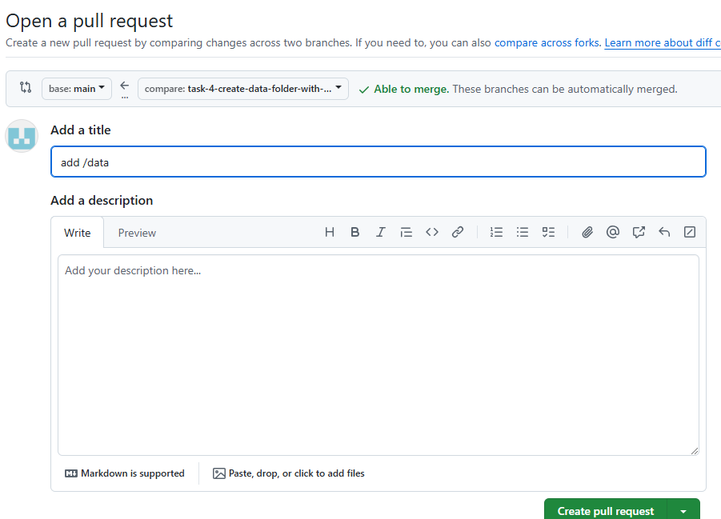 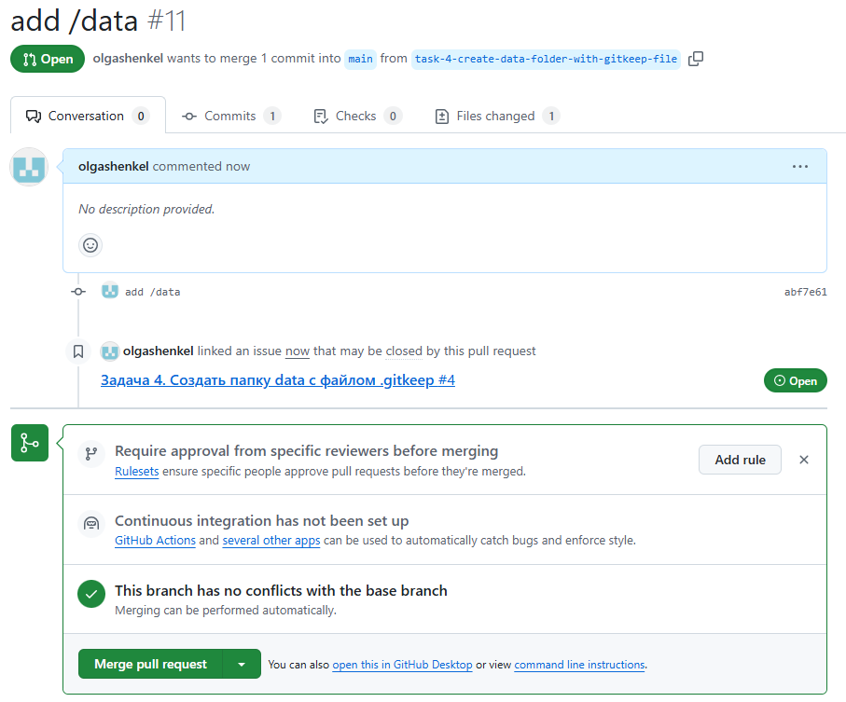

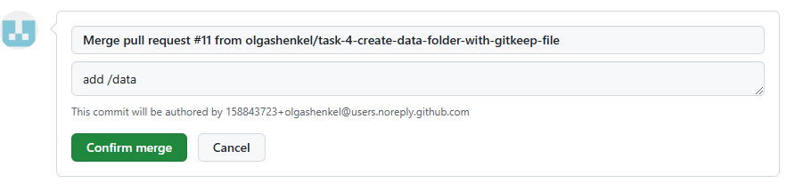

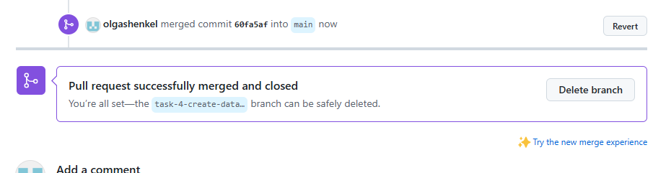

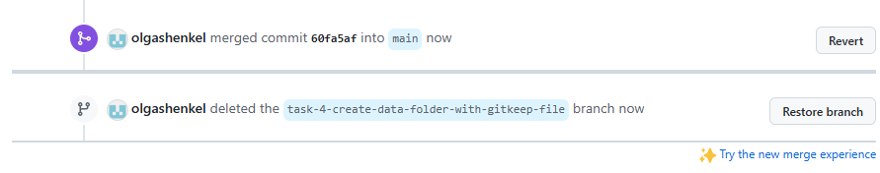

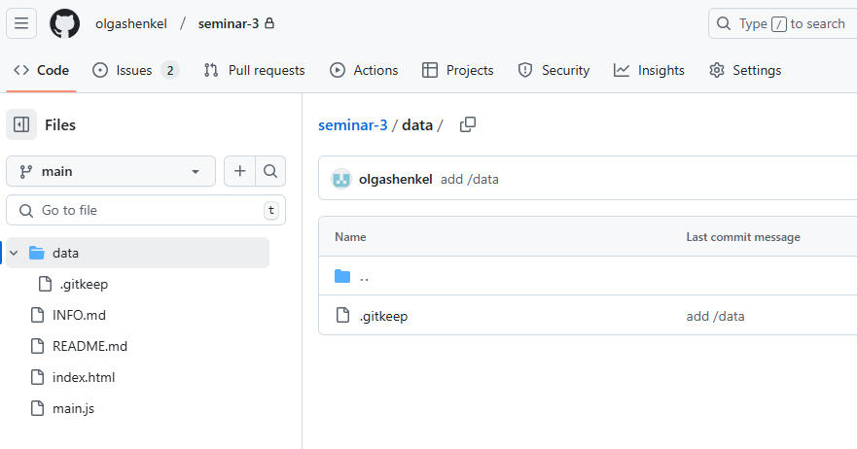

**Ход выполнения задания 2.5.**

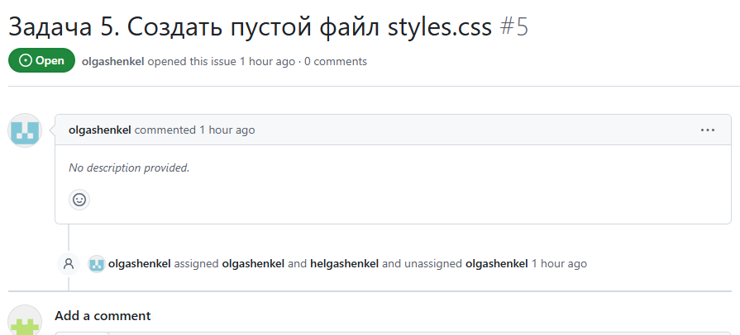 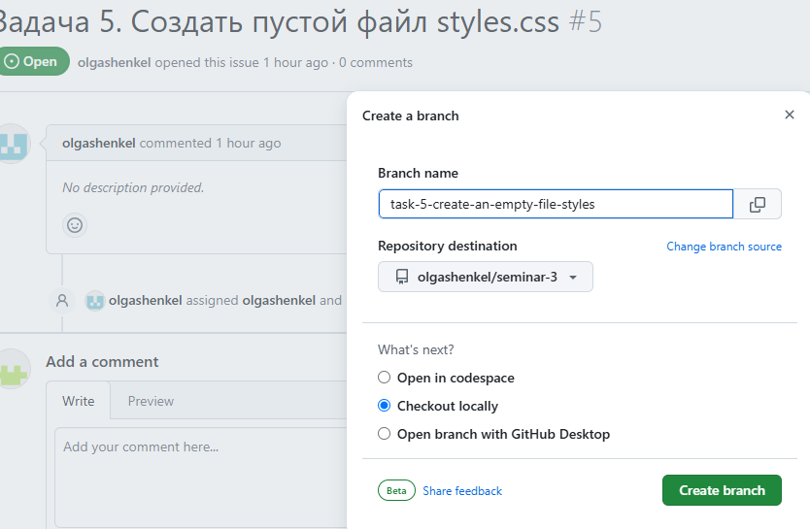

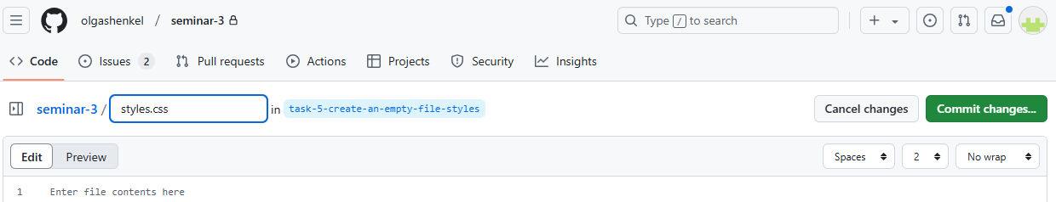

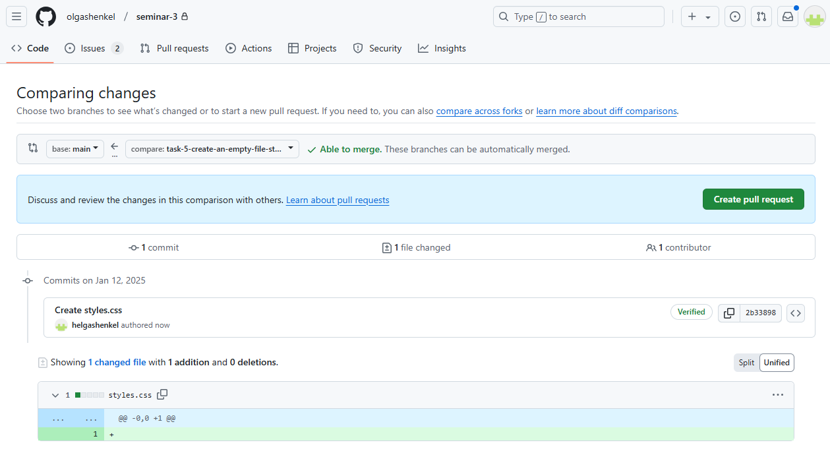

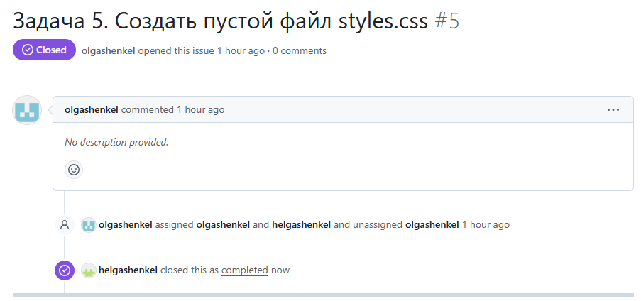

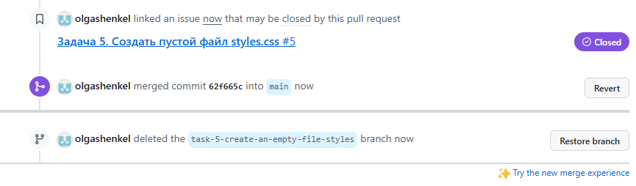

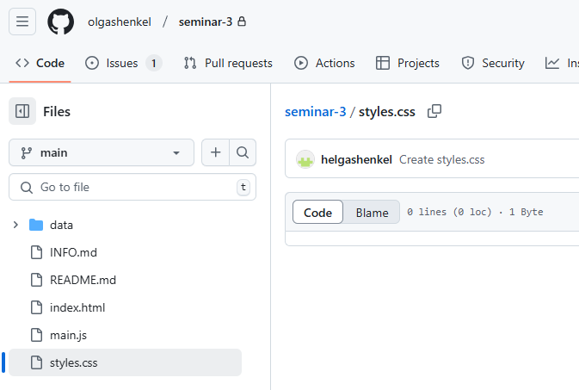

**Ход выполнения задания 2.6.**

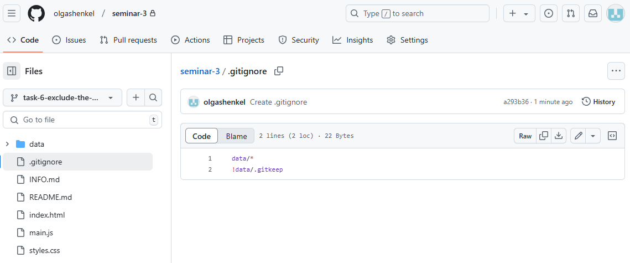

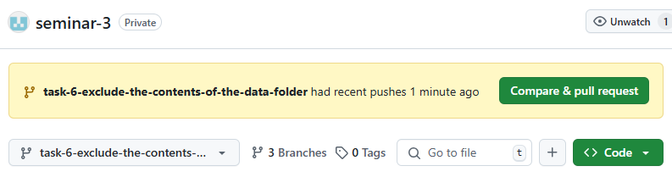

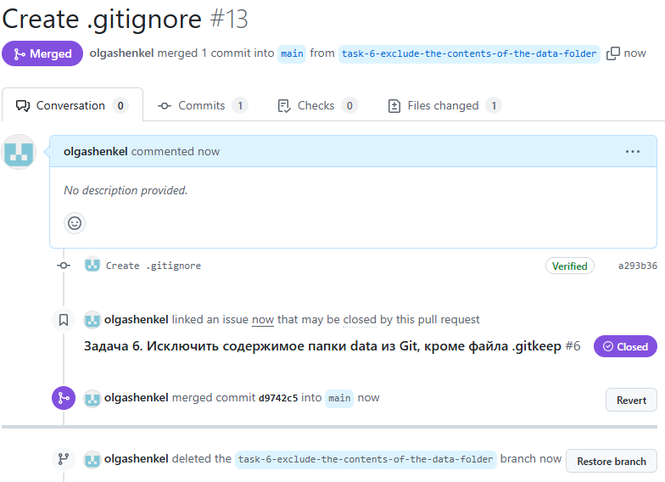

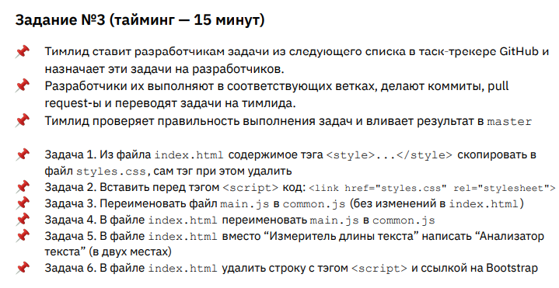

**Ход выполнения задания 3.1.**

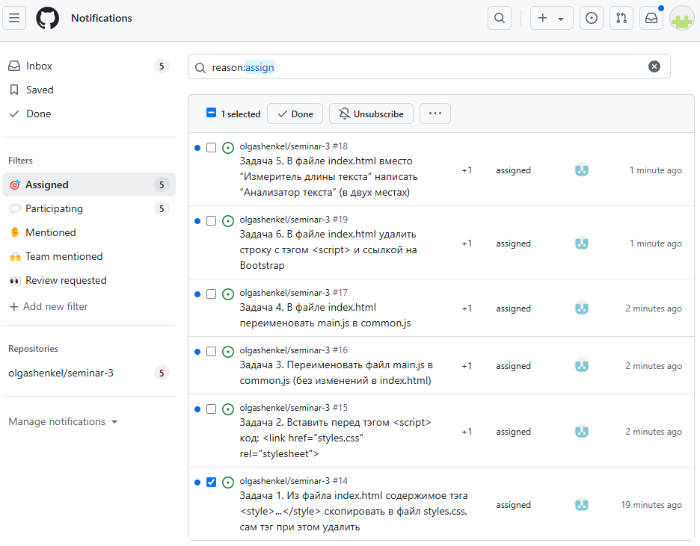

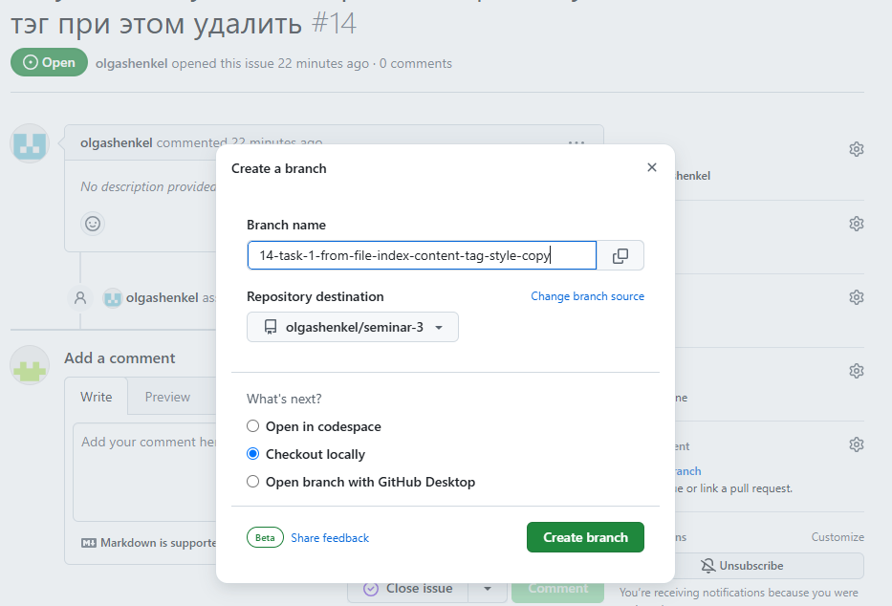

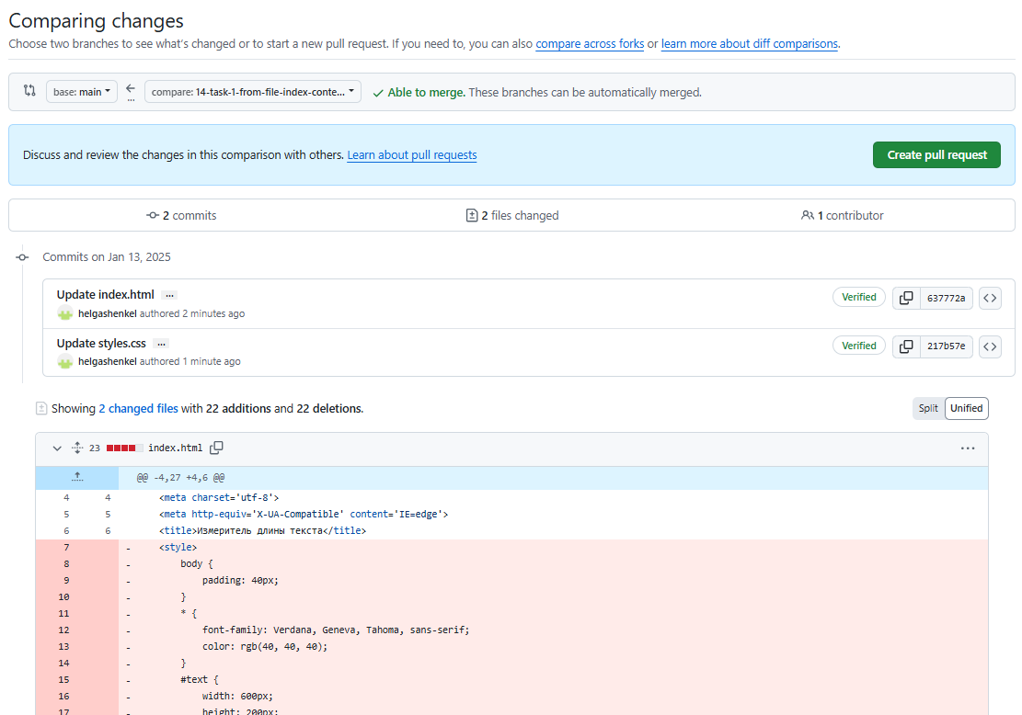 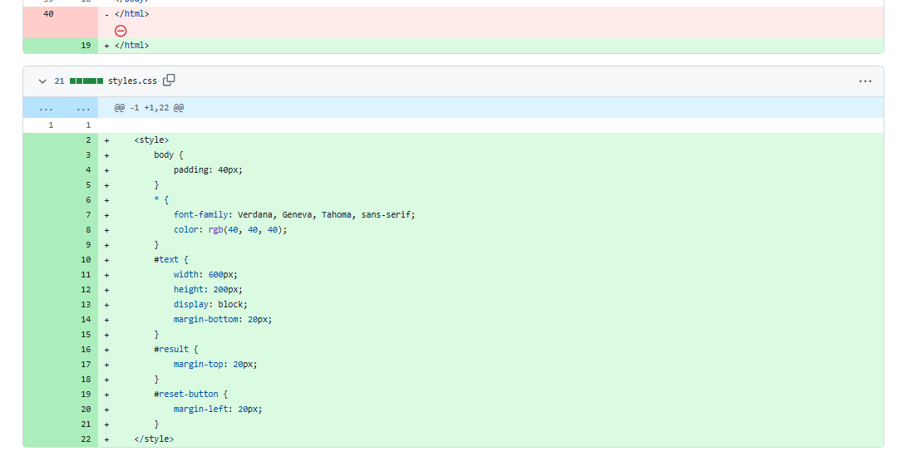

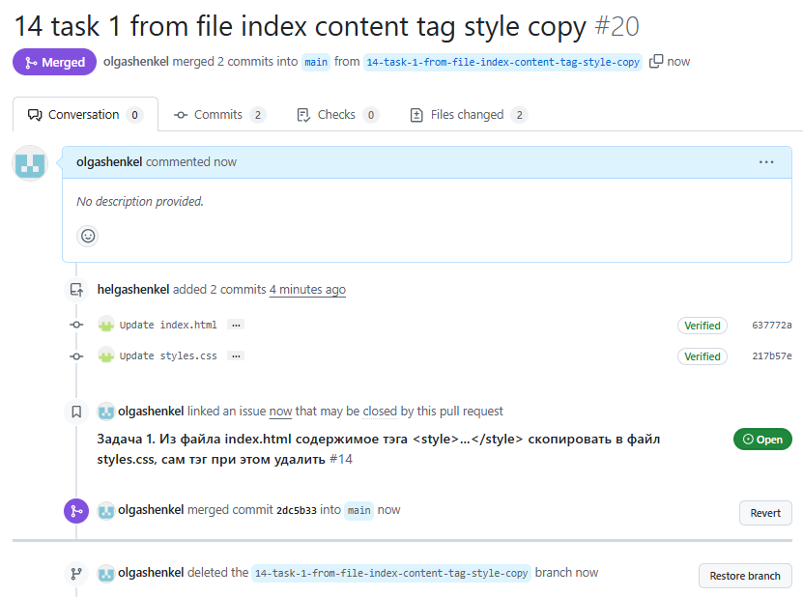

**Ход выполнения задания 3.2.**

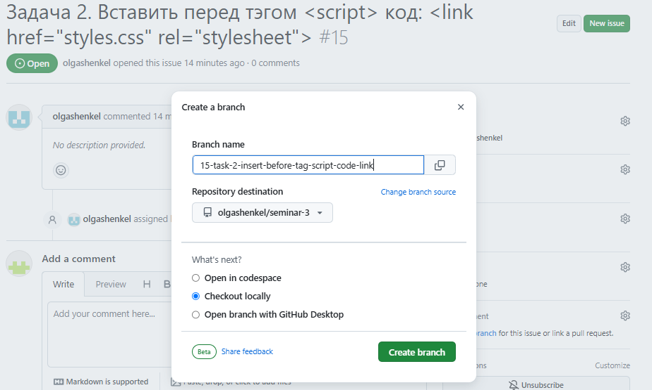 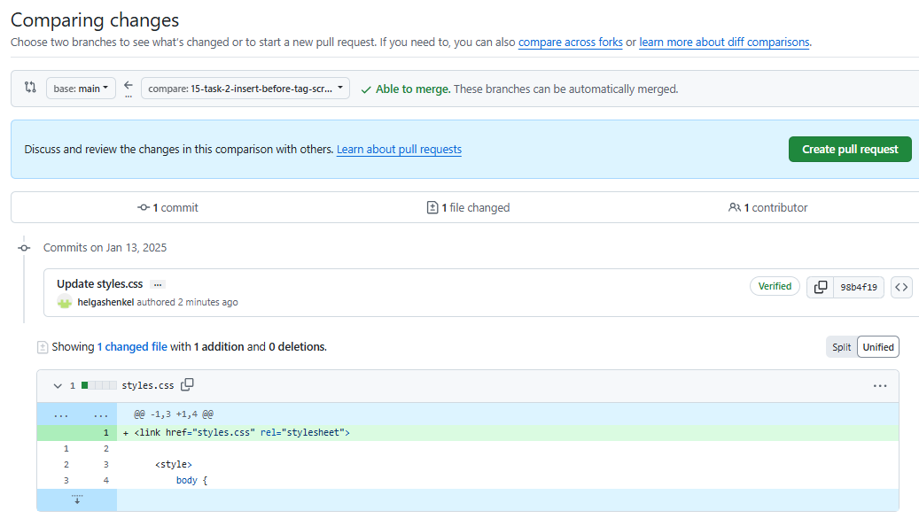

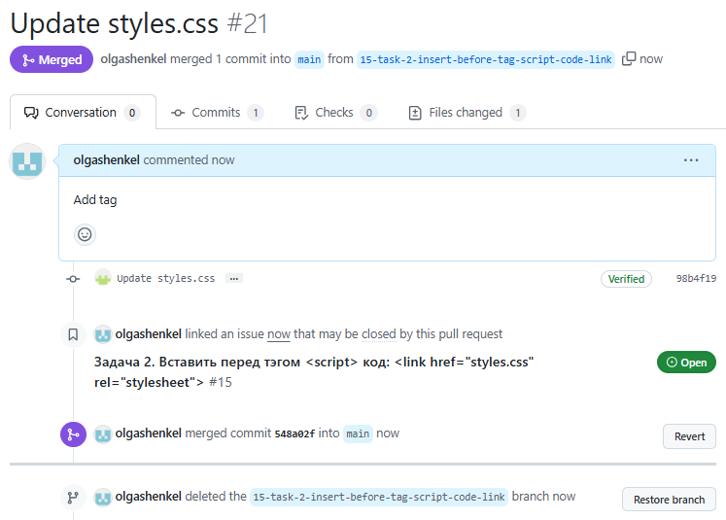

**Ход выполнения задания 3.3.**

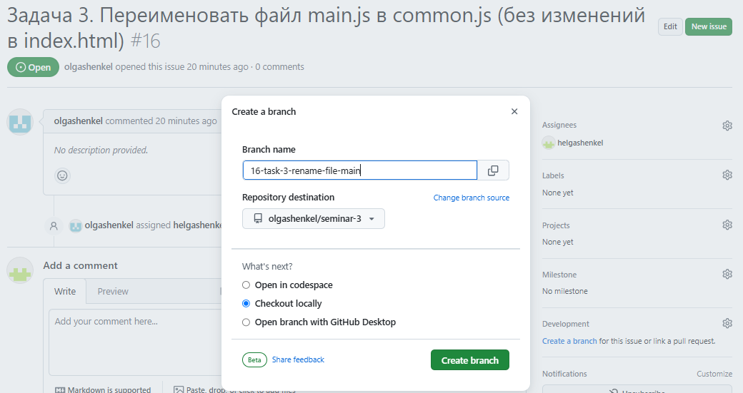

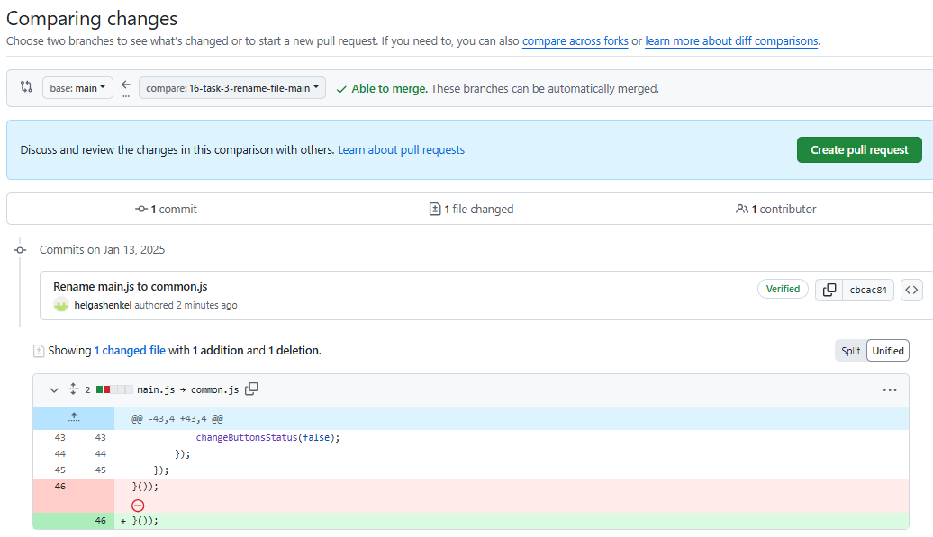

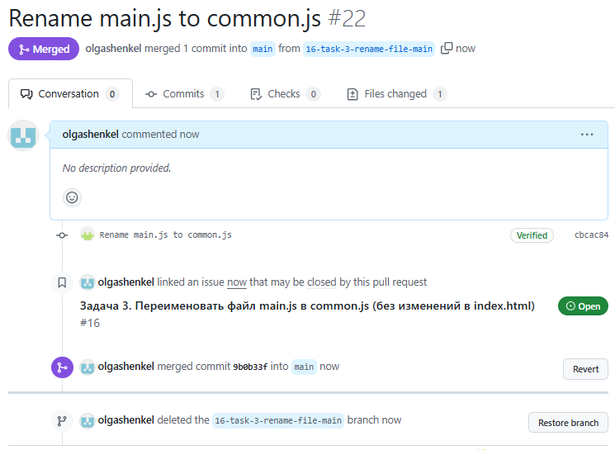

**Ход выполнения задания 3.4.**

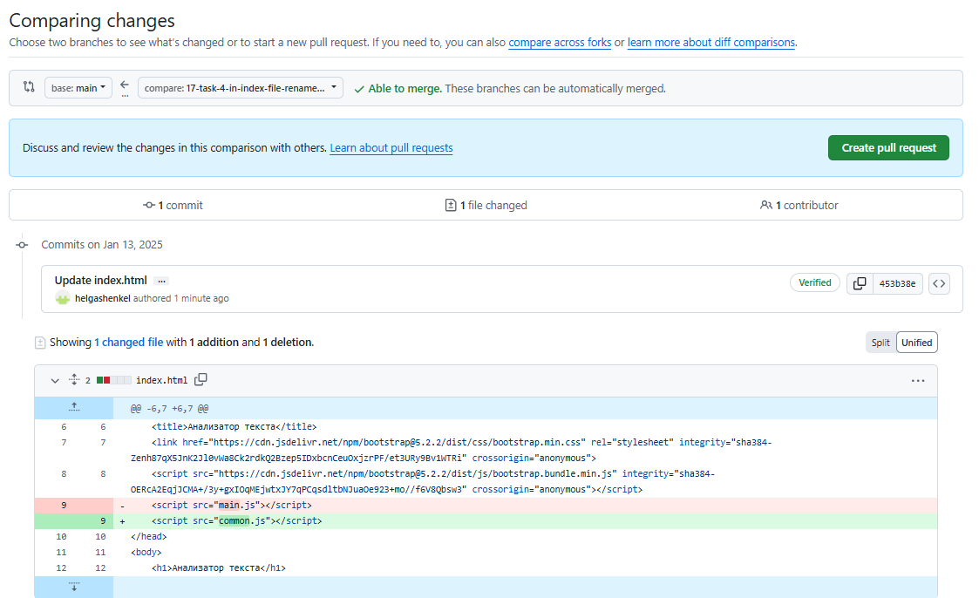

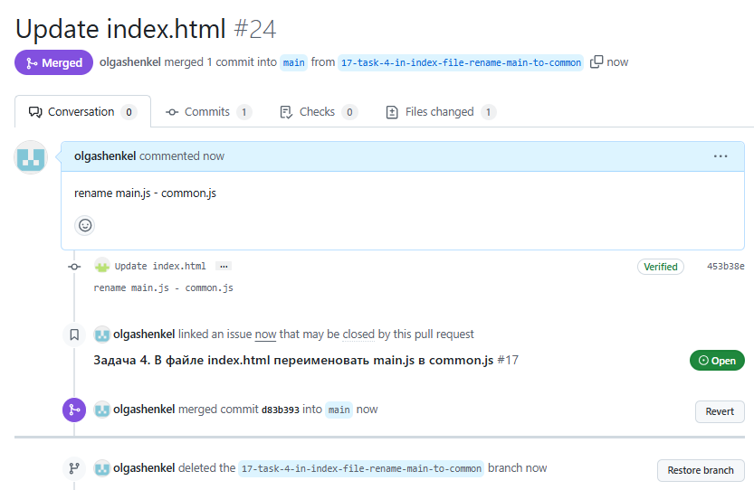

**Ход выполнения задания 3.5.**

**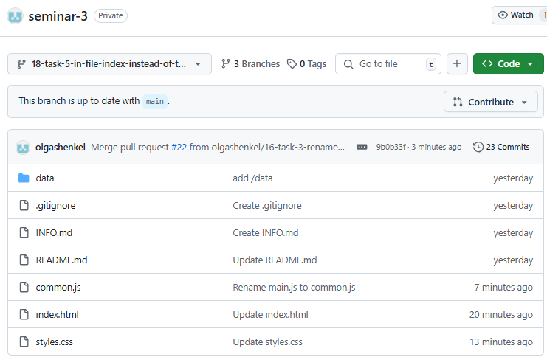 *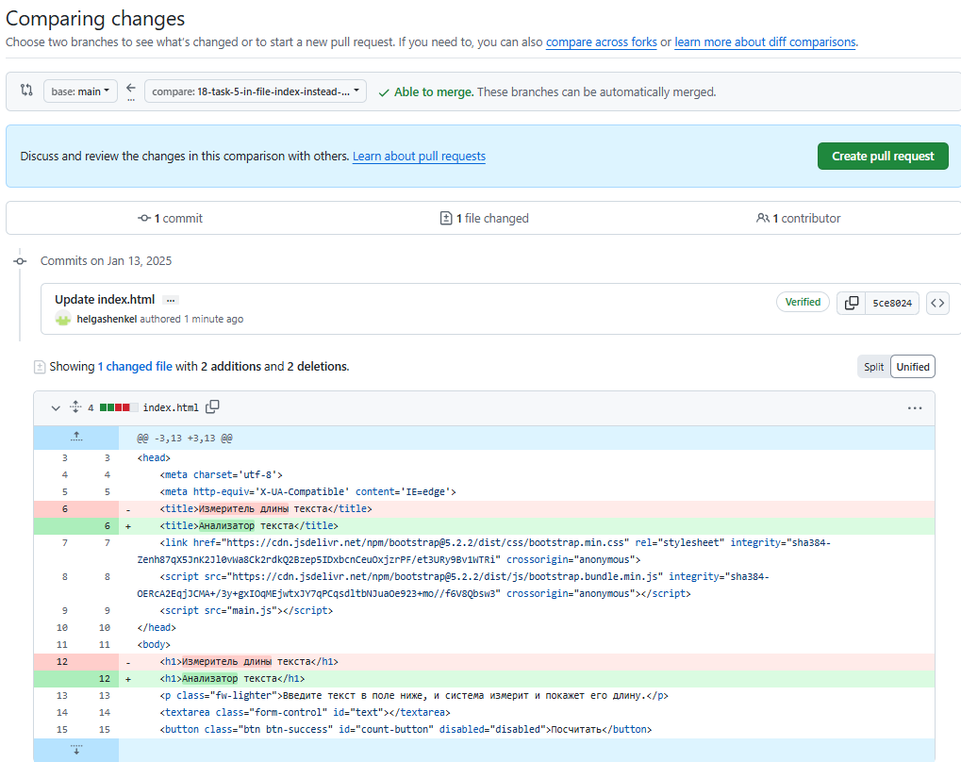***

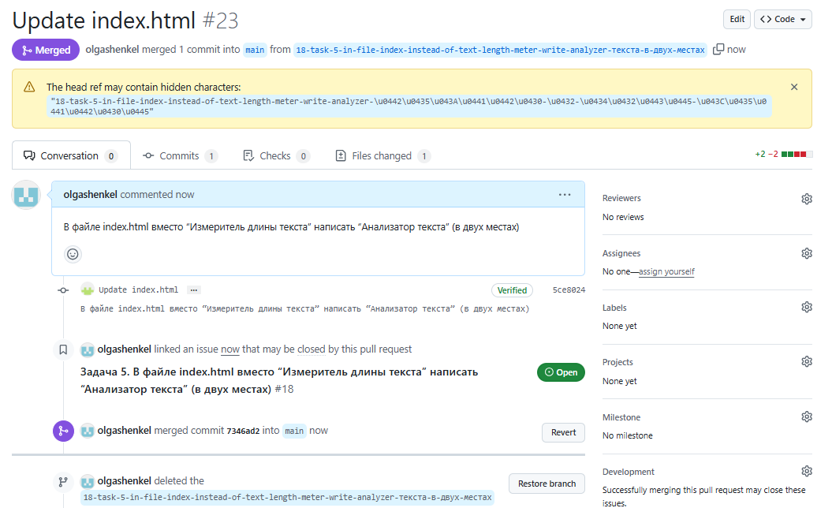

**Ход выполнения задания 3.6.**

